Introducing Berkeley Madonna as a tool for modelling.

Dr Tom Churcher

Part 1: Writing and running your first Berkeley Madonna model

► Open Berkeley Madonna (Start menu: Programs: Berkeley Madonna).You may get one or two warning messages. Just ignore these and click OK.)

A lot more examples can be found in the ‘Help menu’. These also contain answers to some ‘How do I’ questions, as well as the ‘equation guide’ which lists and briefly describes all the functions in Berkeley Madonna.
You will also be given a copy of the manual in the Practical folder.

The first window to open is the equation window.
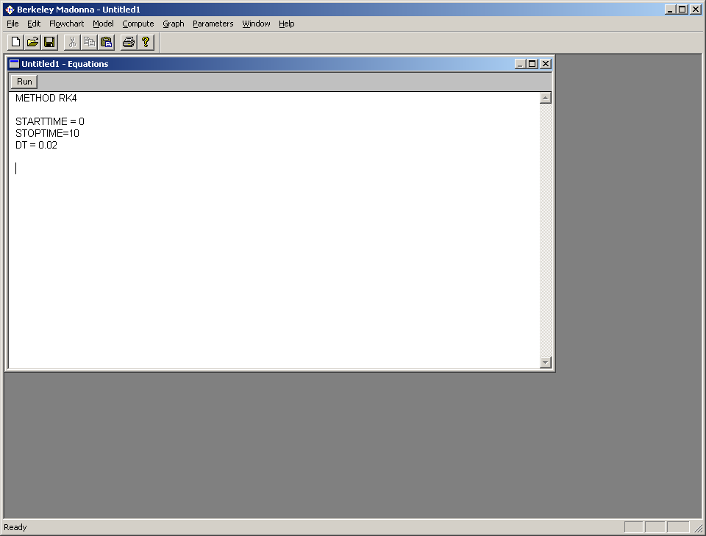

The equation window opens with the following text
METHOD RK4 → This is the numerical integration recipe (in this case the fourth order Runge-Kutta algorithm). Unless you have a very good reason not to, stick with this.
STARTTIME = 0 → This is the time at which the simulation starts.
STOPTIME=10 → This is the time at which the simulation ends.
DT = 0.02 → This is the time step-size used in the numerical integration.

The first model you will solve is that of a population whose size changes at a constant per capita rate and this rate of change is proportional to the population size itself. We denote N(t) the population size at time t and the proportionality constant (which has the dimensions of a rate). In equation form, the model is
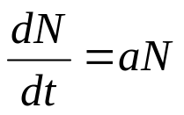
with the initial condition N=N₀ when t=0.
► All notation understood by the programme is outlined in “Equation Help” in the “Help” drop down folder.

► Type in this equation into Berkeley Madonna exactly as follows:
d/dt( N ) = a*N

To fully specify the model, you must also specify the value of the population size at the start (in this case time 0) of the simulation (the initial value N(0)).

► Type in the following:
init N = N0
You must now give some numerical values to the parameters of the model.
► Type:
a = 0.5
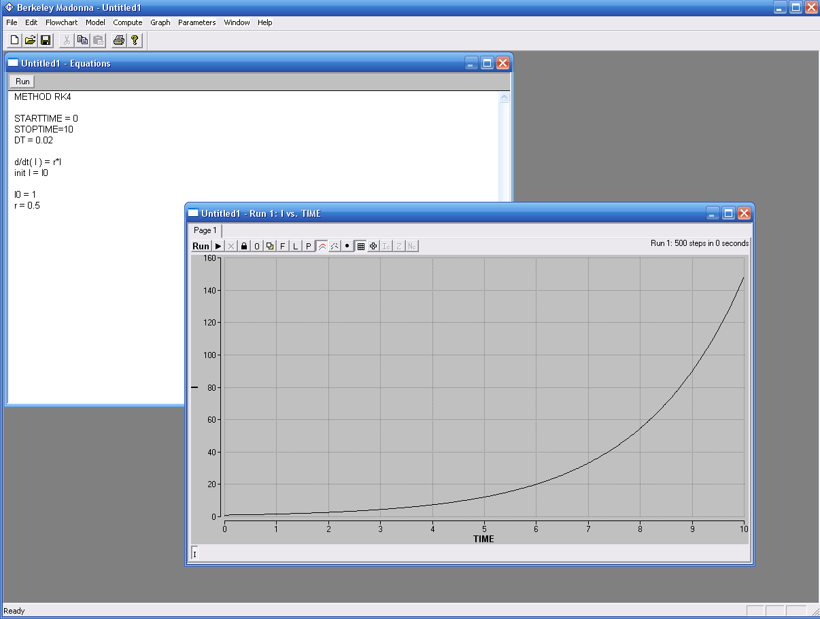
N0 = 1
► Press ‘RUN’ in the equation window:

This opens a new window: a Run window. You can move between windows by clicking on them. The population size N is plotted over time, from time 0 to time 10. It grows exponentially from its initial value of 1.

► Save the file: ‘File menu – Save Model’. Give it a name (e.g. “tutorial1.mmd”). (Don’t forget to save your work regularly).

► In the equation window, change
a = 0.5
to
a = 0.0
and press ‘RUN’ again. Click ‘YES’ when prompted.

The growth rate is 0. The population size N, as seen in the Run window, is now constant over time.
► Open the parameter window: ‘Parameters menu – Parameter window’.

This opens a new window: the Parameter window. In it all the current parameters are listed.
► Click on ‘a’. Change the value to -0.5 Click ‘RUN’.
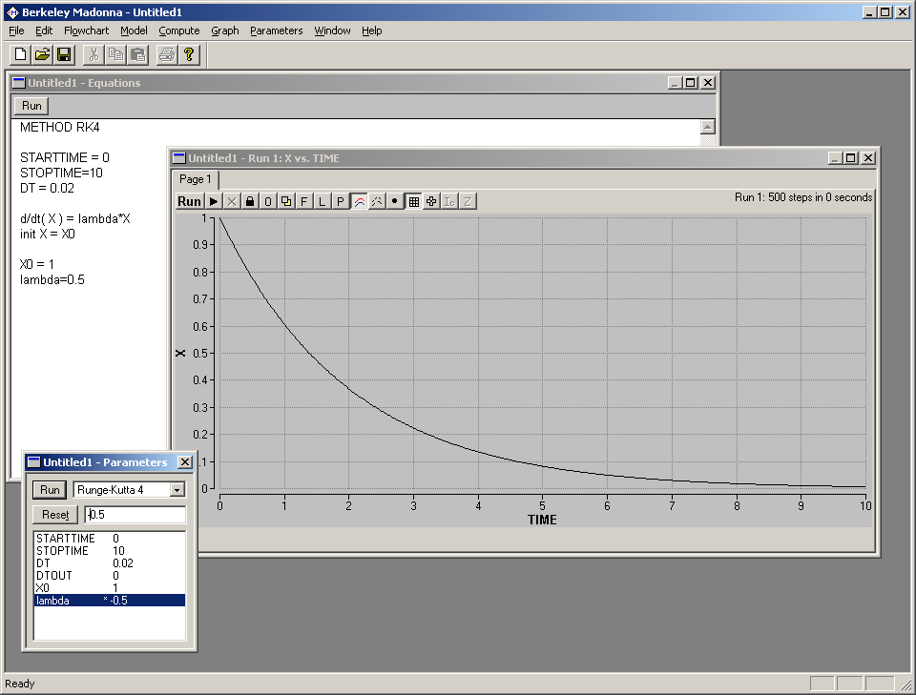
The population size N, as seen in the Run window, now declines exponentially. a is the decay rate.

TIP: Notice that in the Parameter window, there is now a star next to the parameter value a. This star indicates that the value of a is different from the value in the Equation window.

► In the ‘Parameter window’ click on ‘RESET’.
This resets the value to the value of the parameter ‘a’ to be the same as in the Equation window, i.e. 0.5.

► Save and close the model ‘File menu: Close model’
CONFUSINGLY, BERKELEY MADONNA STORES THE VALUE OF PARAMETERS IN THE PARAMETER WINDOW. THIS MEANS THAT THE VALUES DISPLAYED IN THE MAIN WINDOW WHERE THE EQUATIONS ARE WRITTEN CAN GET “OUT OF DATE”.
GOLDEN RULE: IF YOUR PROGRAM IS BEHAVING STRANGELY, ALWAYS TRY RESETING THE PARAMETERS IN THE PARAMETER WINDOW BEFORE ANYTHING ELSE.
Part 2. SIR Model - Closed

This is the basic model used yesterday to describe the dynamics of TB without births and deaths.

Step 1: the model.
The basic closed SIR model is written:
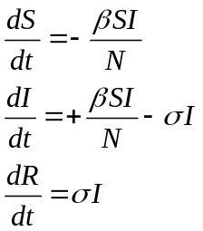

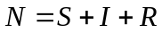

Recall from the lectures that:

- Mean duration of infectiousness =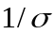

►We are now going to try and write the model from scratch. An example of the code can be found in the ’SIR_Closed.mmd’ from the Practical 2 folder of your course drive (R:) though we strongly encourage you to try and write your own version with the help of the demonstrators without looking at this file.

► It is good practice to comment your work as much as possible so that you can understand what you did when you return to a file. In Berkeley Madonna there are two ways you can insert comments into your code: (1) .Enclose comments in curly brackets, e.g. {this is a comment}or (2) following a semicolon which blocks out any subsequent words or symbols on the same line ;this is a comment .

►To do this open up a new equation window (click on the white piece of paper on the top left hand side) and save the new file to your home folder.

► Write out the equations for the model above. Each state variable (i.e. S, I and R) should be initialised (e.g. init S = …) and defined (e.g. with the d/dt( S ) =…). Note that the initial values should add up to a suitably large population, for example 100,000, and should have at least one infected individual to seed an epidemic. Variables can take any name (eg. beta for ) just as long as there is no repetition and that they are given a value (see section below).

Step 2: Evaluating the parameters.

First, we must choose time units (this is used in the definition of all the parameter values).
We decide to use weeks, with
1 year = 52 weeks (= 364 days (!)).
- The infectious period lasts for 1/2 week, so 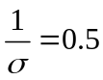 weeks and hence σ = 2 weeks⁻¹
- The transmission parameter value is often unintuitive. We initially take a value of β = 4 weeks⁻¹ and go on to investigate more obvious methods of quantifying transmission later.

► Define each of the parameters used in the model. This is simply done using the equals sign (eg. beta = 4).

Step 3: Running the model

► Run the model by clicking “Run”. The toggles on the bottom (‘S’, ‘I’ and ‘R’) allow you to plot different variables. To add or remove from the choice of variables you can plot, simply double click anywhere in the graph: a dialog box will appear allowing you to add or remove variables, as well as choosing whether to plot them on the right or left axis.

► Press the toggle to see a legend on the graph. Press the toggle to see the parameters. Press the toggle to see the results in table form. Press the toggle again to see the graph. The toggle creates new pages in your window. The 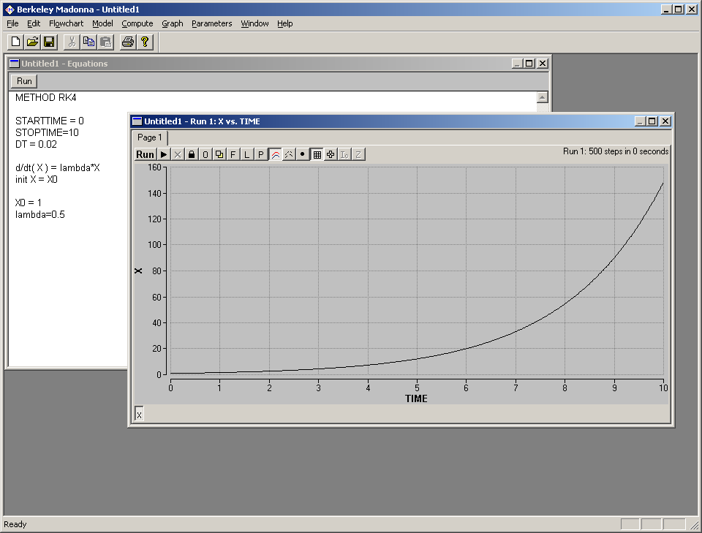 toggle deletes them.

► Click in your graph window. In the ‘File menu’ select ‘Save graph as’. Save your graph. You can use this as a picture to insert into Word or PowerPoint. Press the ‘Table toggle’ (looks like 2 overlapping squares). Your graph will be replaced by a table of values for S, I … at different time points. In the ‘File menu’ select ‘Save table as’. Save this table. You can then import this into Excel or any statistical software to analyze your output (or produce more visually appealing graphs!).

► From the ‘Graph menu’ select ‘Axis settings…’ Tick the ‘log’ box along from ‘Left Y Axis’.
Now, with a log-scale axis, the population changes as a straight line. Notice however how the numbers on the left axis now increase in multiples of 10. This is in fact the definition of a log-scale: exponential growth and decline appears as a straight line. If you want to see whether your data grows or decline exponentially, plot it on a log scale.

► Make the overall population size and the number of initial cases parameters. For example change your initialisers to something like,
init S = N - InfStart
init I = InfStart
init R = 0
making sure to define the new parameters,
N = 1e6 ;total population size
InfStart = 1 ;no of infectious cases at start of epidemic

► Vary all your parameters over a defined range using a parameter slider. Go to the “Parameters” drop down window and select “Define Sliders….”). Add all parameters choosing sensible estimates for the different ranges.

Conduct a sensitivity analysis by varying the parameter values one by one using the sliders. Try pressing the toggle while changing the parameter. This overlays sequential plots. Press the toggle again to stop it doing this.

► Which parameter(s) influence whether or not there is an epidemic, i.e. a peak in the number of cases after the initial introduction (not the size or the speed of the peak)?
The contact rate (beta) and the recovery rate (sigma) both affect whether or not there is an epidemic. The total number of people in the population and the initial number of infected people have no effect on whether there is an epidemic.
By ‘epidemic’ here we mean any increase in the number of infected individuals after the initial introduction, even if not a very large increase.

► For each of these parameters explain in words why there appears to be a threshold value
beneath which there is no epidemic.
The contact rate (beta) – there is no epidemic when beta is too low, because each infected individual contacts few others, reducing transmission.
The recovery rate (sigma) – there is no epidemic when this is too high, because infected individuals recover quickly so that there is little onward transmission.

► Explain in words what is happening to the number of new infectious cases above and below this threshold

Above…Rises initially, eventually peaks and falls if you run the model long enough….

Below…Falls straight away and then approaches zero…………………………………………………….

► Choose 3 different values for sigma and use Berkeley Madonna to numerically find the minimum value of beta that leads to an epidemic within the first year. Any chosen values are fine but you should find the epidemic only occurs when beta is just higher than sigma.
Value of sigma | Minimum value of beta for an epidemic to occur
0.5 | 0.52
0.24 | 0.26
1 | 1.02

► Can you define this threshold mathematically using sigma and beta?
An epidemic occurs when 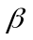 , or:
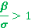

► The Basic Reproduction Number, often denoted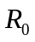 is an expression that plays a key role in epidemiology. At the start of the epidemic, while most people are still susceptible to infection, is the average number of people one infected person newly infects. For an epidemic to occur in a population the newly introduced disease must have a 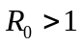.

Knowing the definition of rewrite your epidemic threshold equation in terms of ?
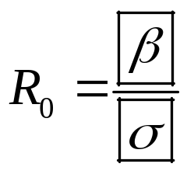

is a central component of theoretical infectious disease epidemiology and you will be hearing plenty more of it in the next two weeks. Mathematical definitions of will depend on the biology of the infection and as a result the structure of the model used to represent it. We shall now go and explore the for other models in the SIR family.

END OF SECTION I
Please tell a demonstrator once you reach here. You may then proceed on to the next section of the practical.

Part 3. SIR Model - Open

This type of model is the same as the one you used yesterday to describe the dynamics of TB. To illustrate the importance of including births and deaths in the system we are going to parameterise the model for a short lived organism.

Step 1: the model.
Births and natural mortality are included within the equations below,
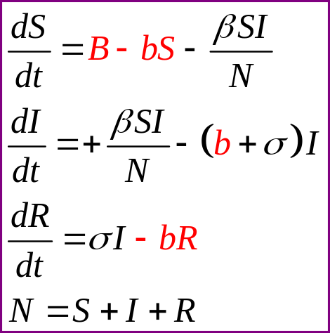

The simplest method of introducing basic demographic processes into the model is to assume all hosts die at a constant death rate. Though this may be an oversimplification for high income countries it has been shown to relatively accurately represent the age distribution of low income populations.
To ensure that there is a constant population size the number of births, B, is adjusted so that N remains constant.

The meaning of the parameters:

- Life expectancy of uninfected =1/b
- Mean duration of infectiousness =1/sigma (conditional on survival)
- Mean duration of infectiousness =1/(b+sigma) (including natural mortality)

Step 2: Evaluating the parameters.
We must choose time units, so again we decide to use weeks,

- Assume the average life-time is 1 year (52 weeks), the natural per-capita mortality rate is: 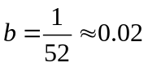per week.
- The population is steady at 10⁵, so the birth rate is:
- 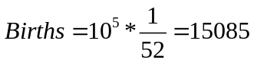per week
- Use the same parameter values as the closed SIR model
- Set the model now runs for 5 years (STOPTIME = 52*5)

Step 3: The program

► Copy the file :’SIR_Open’ from the practical 2 file of your course drive (R:) to your home folder (H:) and open it.

Have a play with the basic model and see how including births and deaths influences disease dynamics.

Using the R0 from the previous section and the parameters above can you derive the R0 for an open SIR model?
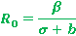
When , and b = 0.02 (all rates are per week),

Programme the R0 expression into Berkeley Madonna and see if your prediction is correct. Note that once you introduce a new term into the equation window, you will need to double click inside the graphics window to ensure the new term is recorded.
You should find that when your R0 is less than 1, there is no epidemic, and when more than one, you have an epidemic (rise in the number of infected cases after the initial introduction)

Investigate the dynamics of the open SIR model. How does it differ from the closed SIR?
In the closed SIR model, the infection dies out. However in the open SIR model there are recurring epidemics because new births provide a supply of susceptibles, allowing the effective (or ‘net’) reproductive number to rise over 1. Recurring epidemics occur more frequently when the birth rate is higher.

Part 4. SEIRS: A generic model of microparasite transmission

The SEIRS model has been described in the lecture.
Consider a measles-like virus spreading in a population of 10,000,000 (or 10⁷ or 1E+7) individuals who have never been exposed to the virus (and who are thus all susceptible to infection).
The virus is readily transmitted primarily by the airborne route, and we assume that the population effectively mixes homogenously, with no subgroup being at increased or reduced risk of infection.
The duration of the latent and infectious period are both approximately 7 days (page 31 Anderson and May). To begin with we assume lifelong immunity. The life expectancy in the population is 75 years, and the case fatality rate is extremely low (almost 0).

Step 1: the model.
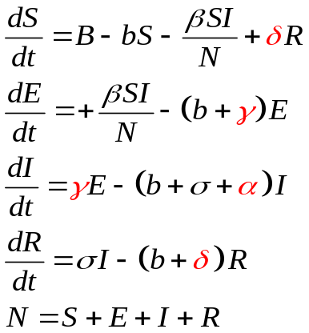
For this situation, the SEIR model seems an appropriate place to start. The model equations are:

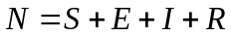

Recall from the lectures the meaning of the parameters:

- Life expectancy of uninfected =1/b
- Mean duration of latency = 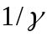 (conditional on survival)
- Mean duration of infectiousness = (conditional on survival)
- Mean duration of immunity = 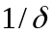 (conditional on survival)
- Disease induced mortality rate α
- Prob. of dying from infection = 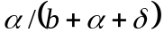

Step 2: Evaluating the parameters.
First, we must choose time units (this is used in the definition of all the parameter values).
Again we decide to use weeks, with

- Since, average the average life-time is 75 years (=75*52=3900 weeks), the natural per-capita mortality rate is: 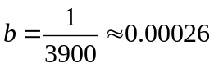per week.

- Few people die from the infection, so 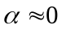.

- Immunity is lifelong, so 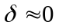(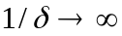).

- The population is steady at 10⁷, so the birth rate is:
- 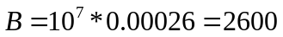 per week

- The latent period lasts 7 days, or 1 week: 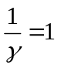 so 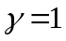
- Similarly, the infectious period lasts 1 week: 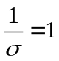so 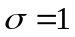

The last parameter we need is beta, the transmission parameter: its value is far from obvious. Instead, we relate it to the basic reproduction number R0, by the formula derived in the lectures:
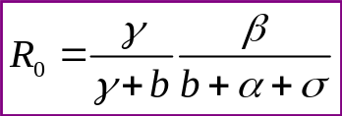

Inverting this equation, relates beta to R₀, so R₀ far becomes the parameter vary, which is much more comprehensible.

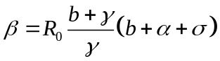

Step 3: The program

► Copy the file :’SEIRS.mmd’ from the course drive (R:) to your home folder (H:).
► In the equation window, change ‘STOPTIME’ to 500.
► From the ‘Parameter menu’ select ‘Define sliders’. Click on ‘delta’. Click on ‘Add’. minimum, enter 0. For maximum, enter 1. For increment, enter 0.001. Click ‘OK’. A parameter slider appears. Move it about with the mouse.
► What is the effect of waning immunity on the long term course of the epidemic?
► How many people are infected at the trough of the inter-epidemic period? What do you think of this? Realistically, what is the longest duration of immunity consistent with the infection reaching a steady endemic state, in this population of 10 million?

You may have noticed that in the equations, ‘beta’ is not a parameter, but is expressed in terms of ‘R0’.

► Define a parameter slider for ‘R0’, ranging from 0 to 10, in steps of 0.1. Try it out.

If you are interested in studying more systematically the effect of ‘R0’ on the long-term outcome of infection, we could do it as follows:
► Use the parameter window to set the rate of loss of immunity to a high value (e.g. 0.1), so that an endemic state is reached rapidly. Select ‘Batch runs’ from the ‘Parameter’ menu. Choose ‘R0’ from the drop-down parameter list. Enter ‘# runs’ = 21, ‘Initial value’=0, ‘Final value’=10. Leave ‘Series type’ set on arithmetic and ‘Mode’ on ‘Keep runs separate’. Click OK. Try leaving only ‘I’ highlighted on the bottom. You show now see lots of epidemic curves with differing values of R₀.
If you are interested in studying more systematically the effect of ‘R0’ on the final endemic prevalence of infection, try:
► Select ‘Parameter plot’ from the ‘Parameter’ menu. Choose ‘R0’ from the drop-down parameter list. Enter ‘# runs’ = 501, ‘Initial value’=0, ‘Final value’=10. Choose the variable ‘I’, and add it. Tick ‘Final’. Run it (it will take a couple of minutes).
The new window shows the final number of people infected (500 years after the introduction of the disease into the population) as a function not of time, but of the basic reproduction number R₀.
► Can you explain what happens when R₀=1? This is known as a threshold.

TIP: There are other Berkeley Madonna files on the network drive for the other types of models discussed: you are welcome to load them and explore their behaviour too.
END OF PRACTICAL
Coding resource (all found in equation help)

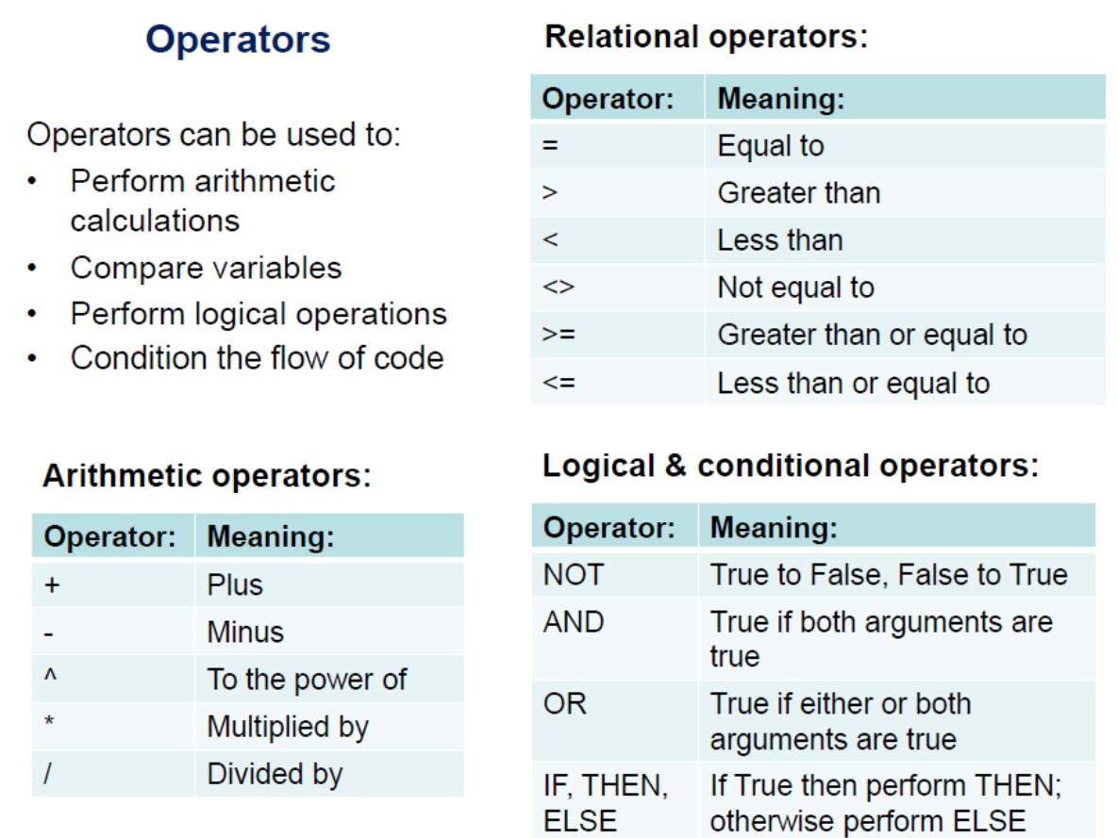

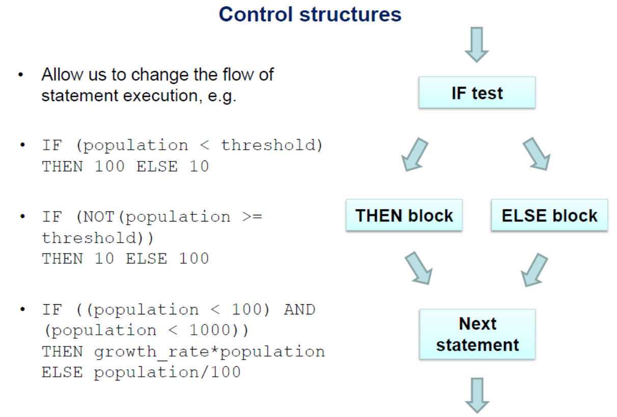
Vectors

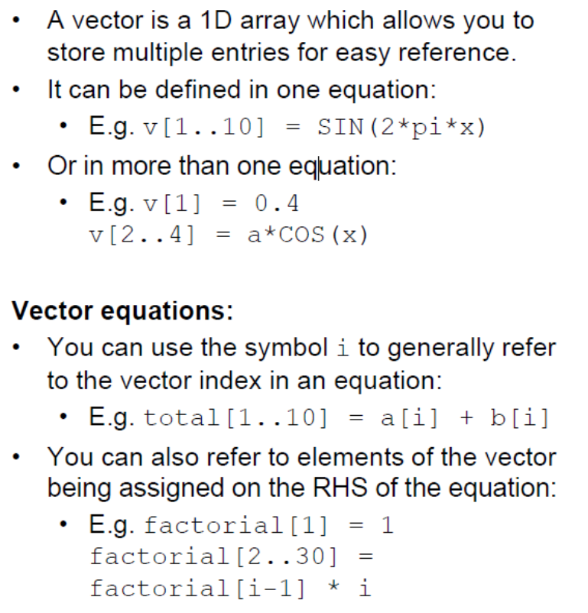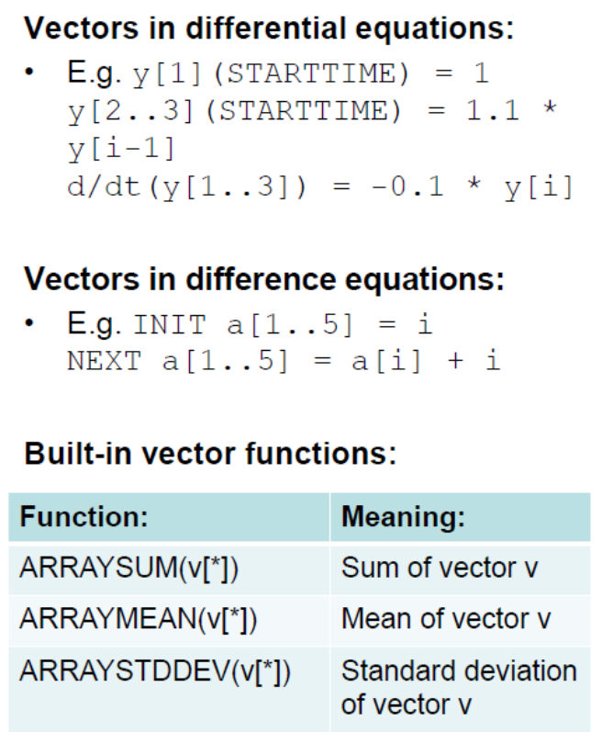

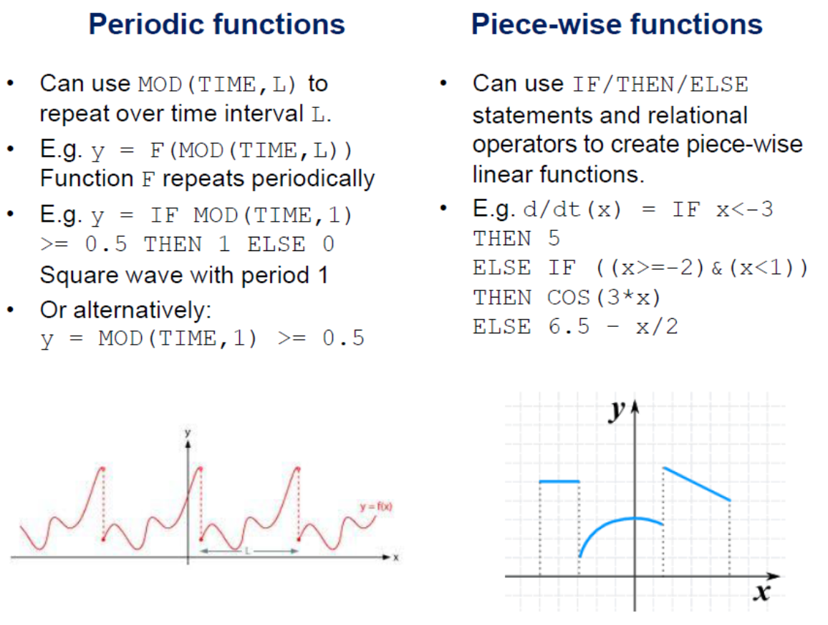

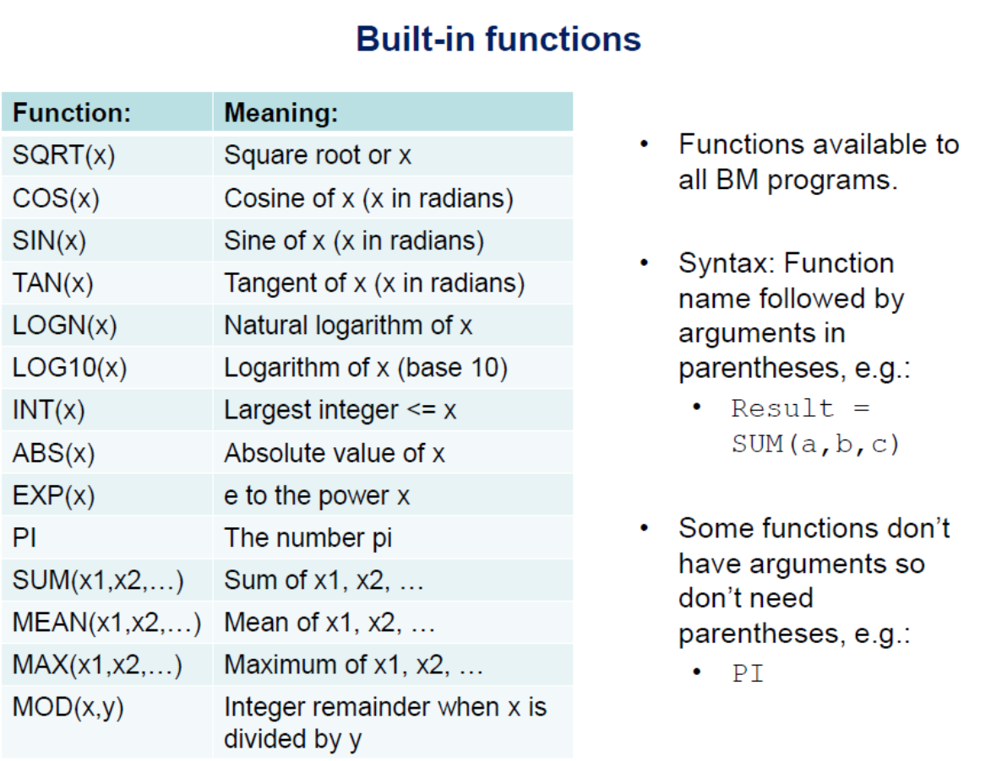

Sample code

SEIRS model
METHOD RK4

STARTTIME = 0
STOPTIME=52
DT = 0.02
WEEKS = TIME

d/dt( S ) = Births - b*S - beta*S*I/N + delta*R
d/dt( E ) = beta*S*I/N - (b+gamma)*E
d/dt( I ) = gamma*E - (b+alpha+sigma)*I
d/dt( R ) = sigma*I - (b+delta)*R

init S = N0 - I0
init E = 0
init I = I0
init R = 0

N = S+E+I+R

N0 = 1E+7
I0 = 1

Births = b*N0
b = 2.6e-4
gamma = 1
sigma = 1
alpha = 0
delta = 0

R0 = 5
beta =R0 * ((b+gamma)/gamma) * (b+alpha+sigma)

Closed SIR model
METHOD RK4

STARTTIME = 0
STOPTIME=52
DT = 0.02
WEEKS = TIME

;Variables
d/dt( S ) = -beta*S*I/N
d/dt( I ) = beta*S*I/N - sigma*I
d/dt( R ) = sigma*I

;Inital conditions of the variables
init S = N - InfStart
init I = InfStart
init R = 0

;Parameter values
sigma =2 ;recovery rate (1/Mean duration of infectiousness)
beta =4 ;transmission parameter (p*c)

N = 1e6 ;total population size
InfStart = 1 ;number of infectious cases at start of epidemic

Open SIR model
METHOD RK4

STARTTIME = 0
STOPTIME=52
DT = 0.02

;Variables
d/dt( S ) = Births - b*S - beta*S*I/N
d/dt( I ) = beta*S*I/N - (b+sigma)*I
d/dt( R ) = sigma*I - b*R

;Inital conditions of the variables
init S = N - InfStart
init I = InfStart
init R = 0
pop=S+I+R

;Parameter values
sigma =2 ;recovery rate (1/Mean duration of infectiousness)
beta =R0*(sigma+b) ;transmission parameter (p*c)
R0=1

N = 1e6 ;total population size
InfStart = 1 ;number of infectious cases at start of epidemic
b = 1/52 ;death rate (average life expectancy of 1 year)
Births = (S+I+R)*b ;number of births (for a constant population size)

